**Bug Report**

**Bug #1**

**The title of the page is "QE tdolist" instead of "QE todolist"**

**Steps to Replicate**

1. Navigate to the page <http://localhost:8080/todo>
2. Check the title of the page
3. Notice that the title of the page says "QE tdolist" instead of "QE todolist"

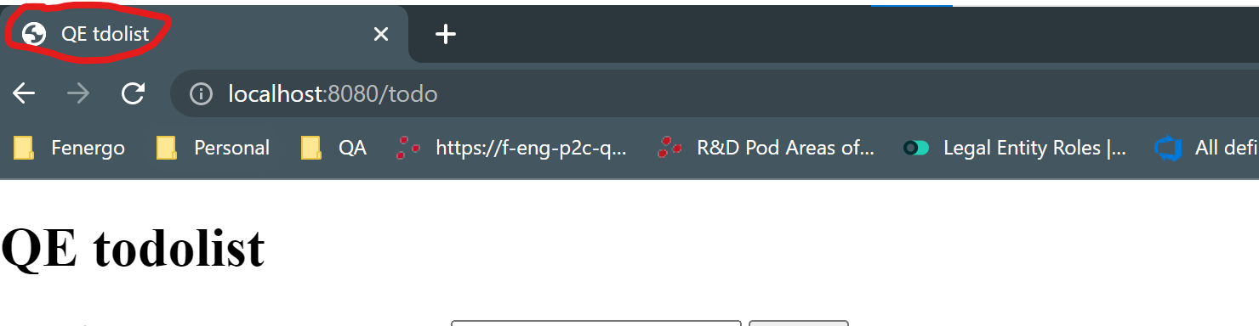

**Bug #2**

**- Clicking the "Update" button next to the item entry results in the item being removed**

**Steps to Replicate**

1. Add a ToDo item on <http://localhost:8080/todo>
2. Go to any of the added ToDo items
3. Click on the Update button without entering any value on the update field
4. Notice the ToDo item has been removed from the list

**Expected Behavior:** When the user clicks on the Update button without entering the item to update, there should be an error message presented to the user

**Current Behavior:** When the user clicks on the Update button without entering the item to update, the user is able to SAVE the empty string

**Bug #3**

**- Items added through the api are not reflected in the UI of the application**

**Steps to Replicate**

1. Go to Postman and add a new todo item using the API call <http://localhost:8080/todo/add/>

**Expected Behavior:** The item added is being displayed in the UI of the application

**Current Behavior:** The item is added to the UI but the input is not shown

